- Static Routing Concepts Theory

Q1. Open Cisco Packet Tracer and set up a simple network with two routers connected via a serial cable, assigning IP addresses to both router interfaces?

Answer
- I created a simple network in Cisco Packet Tracer using two 2811 routers connected with a Serial cable. I assigned IP address 195.168.1.1/30 to Router0 and 195.168.1.2/30 to Router1.
- After configuring both routers, I tested the connectivity using the ping command. The ping was successful with a 100% success rate (5/5).
- Result: Both routers are successfully connected and communicating with each other.

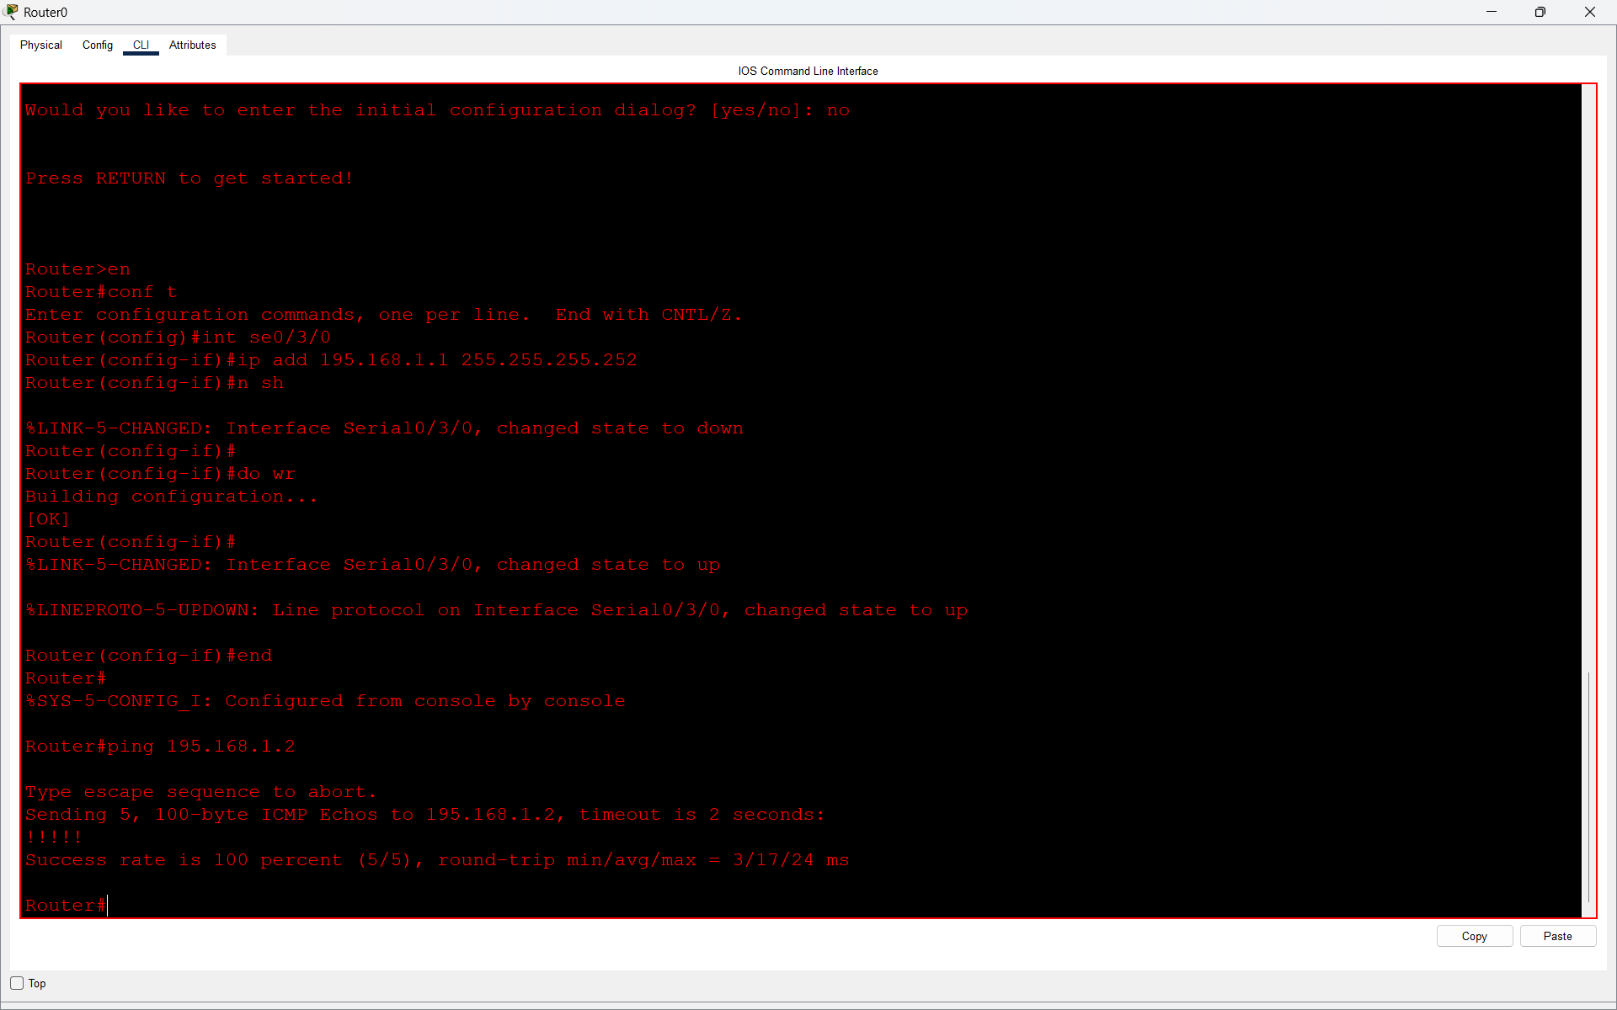
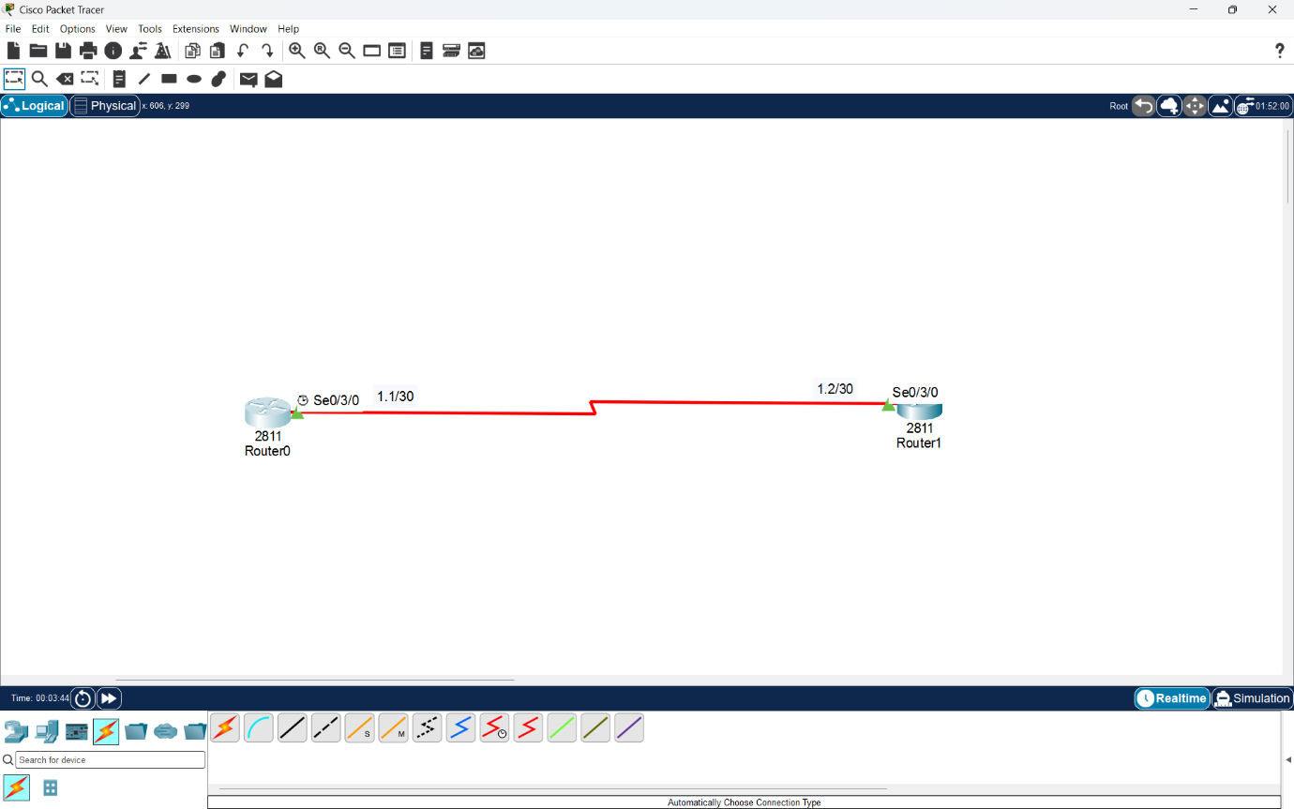

Q2. On Router1 in Cisco Packet Tracer, configure a static route so it can reach a PC connected to Router2’s LAN network. Test connectivity using the ping command from Router1 to the PC?

Answer
- In Cisco Packet Tracer, I connected two routers using a serial cable and connected two PCs to Router1 through a switch.
- I configured the LAN network using the /26 subnet mask and enabled DHCP on Router1 to assign IP addresses to the PCs automatically.
- After that, I configured a static route on Router0 using the command:
ip route 195.168.1.64 255.255.255.192 195.168.1.2
- Then I tested the connection by pinging PC0 (195.168.1.66) from Router0.
- Result: The ping was successful with a 100% success rate (5/5). This shows that static routing is working properly.
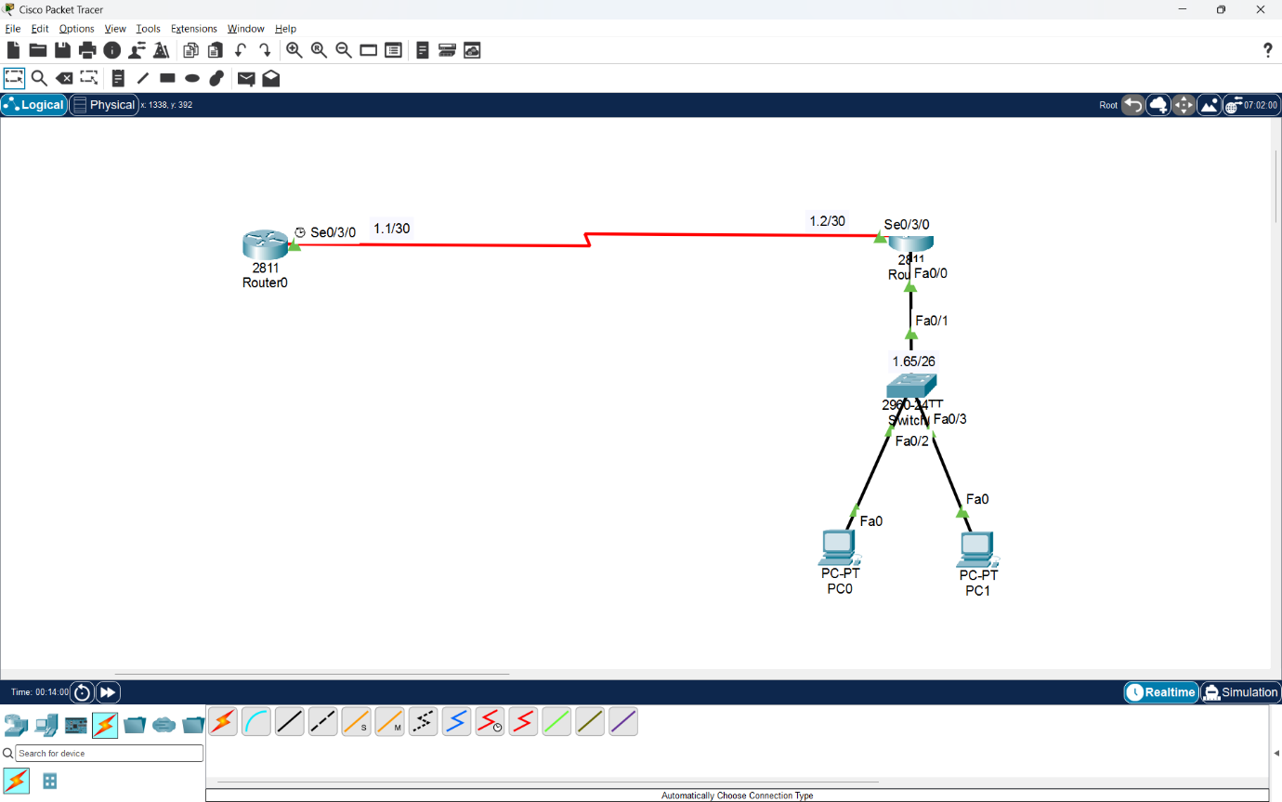

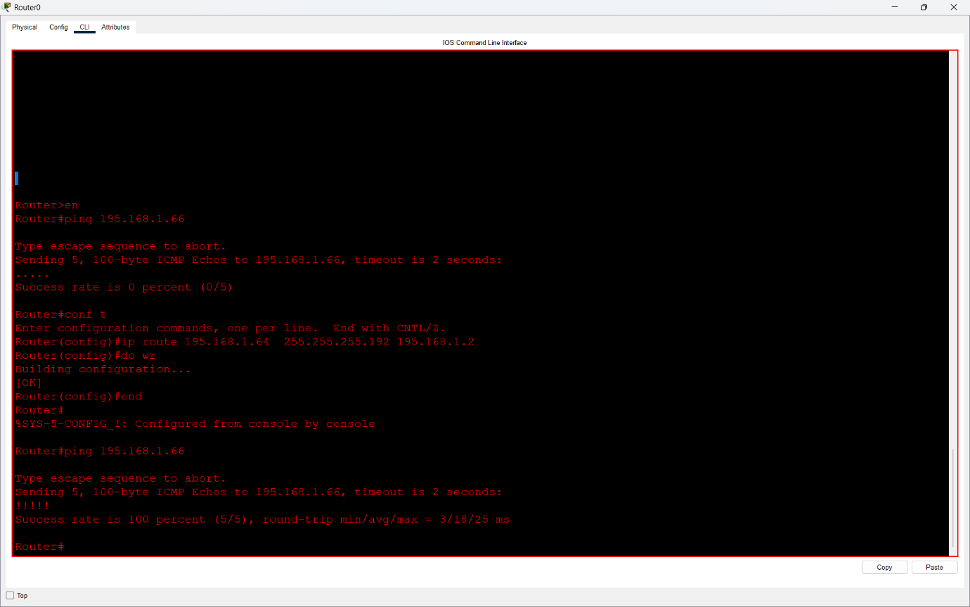

Q3. Simulate a Zomato-style delivery network: imagine Router1 represents an Ahmedabad branch and Router2 represents a Surat branch. Configure static routes so that devices in each city’s LAN can communicate with each other through the routers?

Answer
- I created a Zomato-style delivery network in Cisco Packet Tracer using two routers. Router0 represents the Ahmedabad branch, and Router1 represents the Surat branch.
- I connected two PCs to each router through switches and configured DHCP for automatic IP address allocation.
- I used 195.168.1.128/26 for Ahmedabad LAN and 195.168.1.64/26 for Surat LAN.
- Then I configured static routes on both routers to enable communication between the two cities.
- Ahmedabad Router0:
ip route 195.168.1.64 255.255.255.192 195.168.1.2
- Surat Router1:
ip route 195.168.1.128 255.255.255.192 195.168.1.1
Finally, I tested the network by sending packets between Ahmedabad and Surat PCs.
- Result: All packets were successfully delivered, showing that static routing is working properly between both branches.

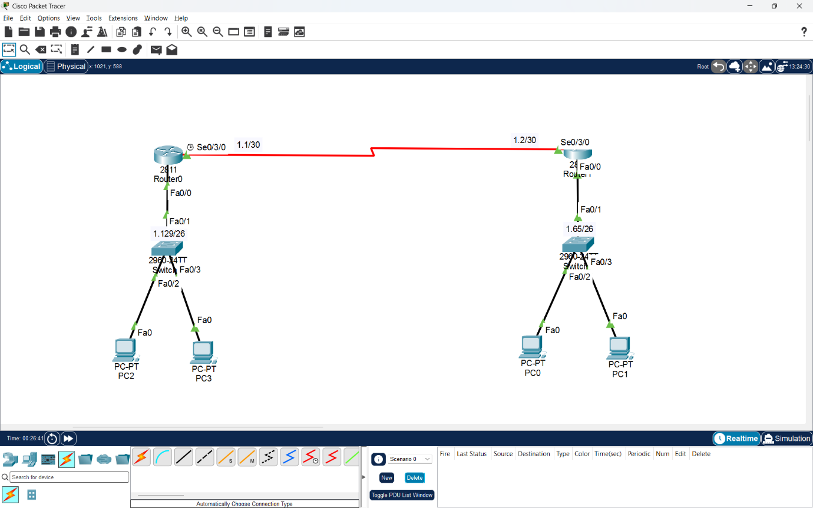
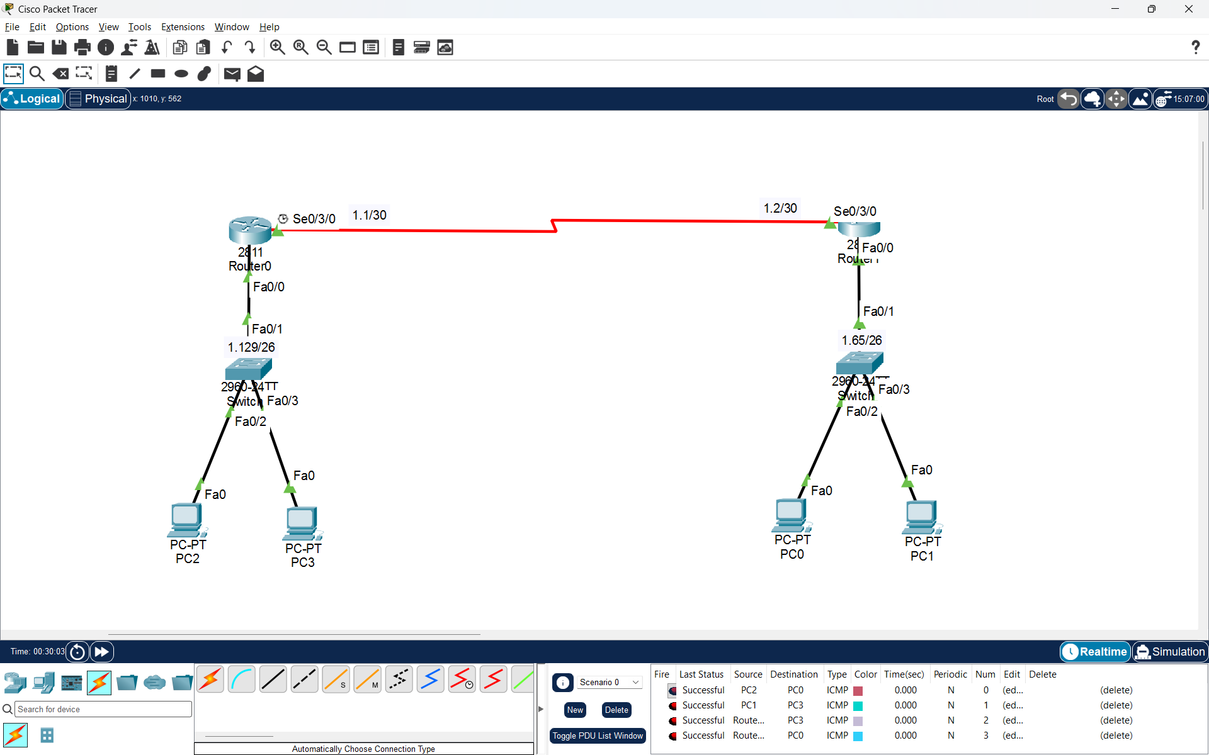

Q4. List two advantages and two disadvantages of static routing compared to dynamic routing, using examples from real-life apps like IRCTC or Swiggy to illustrate your points.<br><br><em><strong>Hint:</strong> Think about how static routes might impact delivery or booking updates in these apps.</em>?

Answer
Static routing is a routing method in which network routes are manually configured by the network administrator. In dynamic routing, routers automatically learn and update routes.
- Advantages of Static Routing
1. Easy to Configure
    - Static routing is simple to configure and manage in small networks.
    - Example: If Swiggy has only two branch offices connected through a fixed network, static routing can be used for communication between them.
2. Less Network Traffic
    - Static routing does not send regular routing updates, so it saves network bandwidth and router resources.
    - Example: In a small IRCTC office network, static routing can reduce unnecessary routing traffic, leaving more bandwidth available for booking-related data.
- Disadvantages of Static Routing
1. No Automatic Route Updates
    - If a network connection fails, static routing does not automatically find another path unless a backup route is configured.
    - Example: If Swiggy's network connection between two branches fails, delivery updates may be delayed until the network route is restored or changed.
2. Difficult to Manage Large Networks
    - In large networks, manually configuring routes on every router takes more time and effort.
    - Example: IRCTC has many connected systems. If the network grows or changes, updating static routes manually can become difficult.
- Conclusion
Static routing is useful for small and stable networks because it is simple and uses fewer resources. However, dynamic routing is better for large networks because it can automatically update routes when network changes occur.

